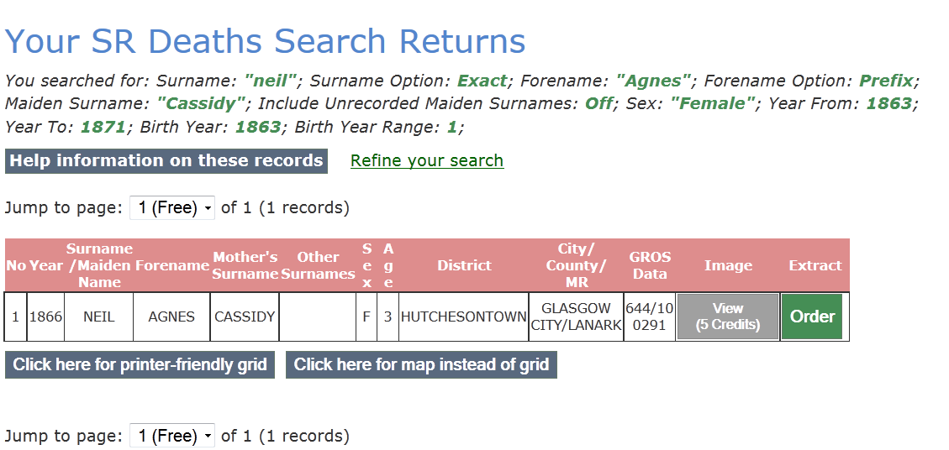

Your SR Deaths Search Returns
You searched for: Surname: "neil"; Surname Option: Exact; Forename: "Agnes"; Forename Option: Prefix; Maiden Surname: "Cassidy"; Include Unrecorded Maiden Surnames: Off; Sex: "Female"; Year From: 1863; Year To: 1871; Birth Year: 1863; Birth Year Range: 1;
Refine your search
Jump to page: of 1 (1 records)
No | Year | Surname  /Maiden Name | Forename | Mother's  Surname | Other  Surnames | S  e  x | A  g  e | District | City/  County/  MR | GROS  Data
1 | 1866 | NEIL | AGNES | CASSIDY |  | F | 3 | HUTCHESONTOWN | GLASGOW CITY/LANARK | 644/10 0291

