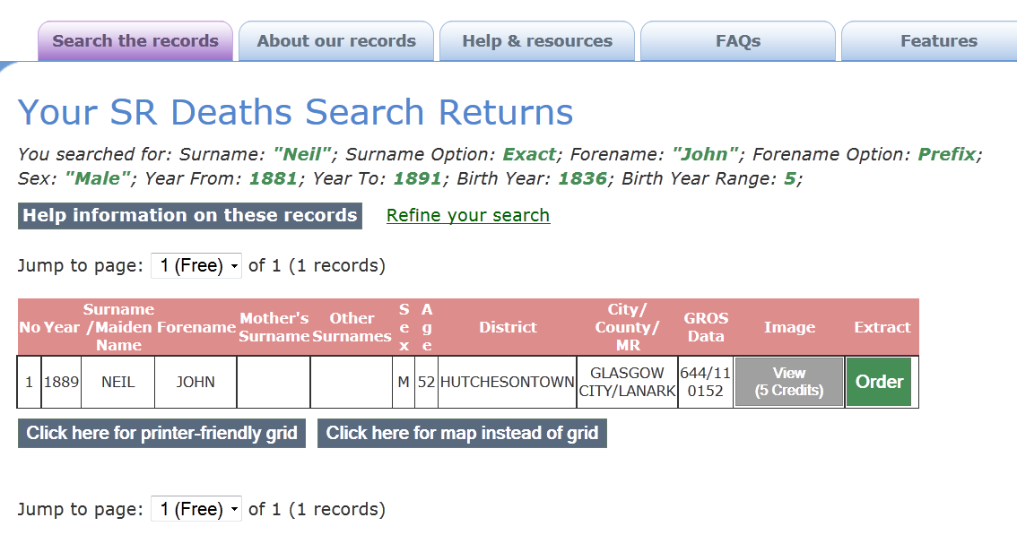

Your SR Deaths Search Returns
You searched for: Surname: "Neil"; Surname Option: Exact; Forename: "John"; Forename Option: Prefix; Sex: "Male"; Year From: 1881; Year To: 1891; Birth Year: 1836; Birth Year Range: 5;
Help information on these records Refine your search
Jump to page: of 1 (1 records)
No | Year | Surname  /Maiden Name | Forename | Mother's  Surname | Other  Surnames | S  e  x | A  g  e | District | City/  County/  MR | GROS  Data | Image | Extract
1 | 1889 | NEIL | JOHN |  |  | M | 52 | HUTCHESONTOWN | GLASGOW CITY/LANARK | 644/11 0152

