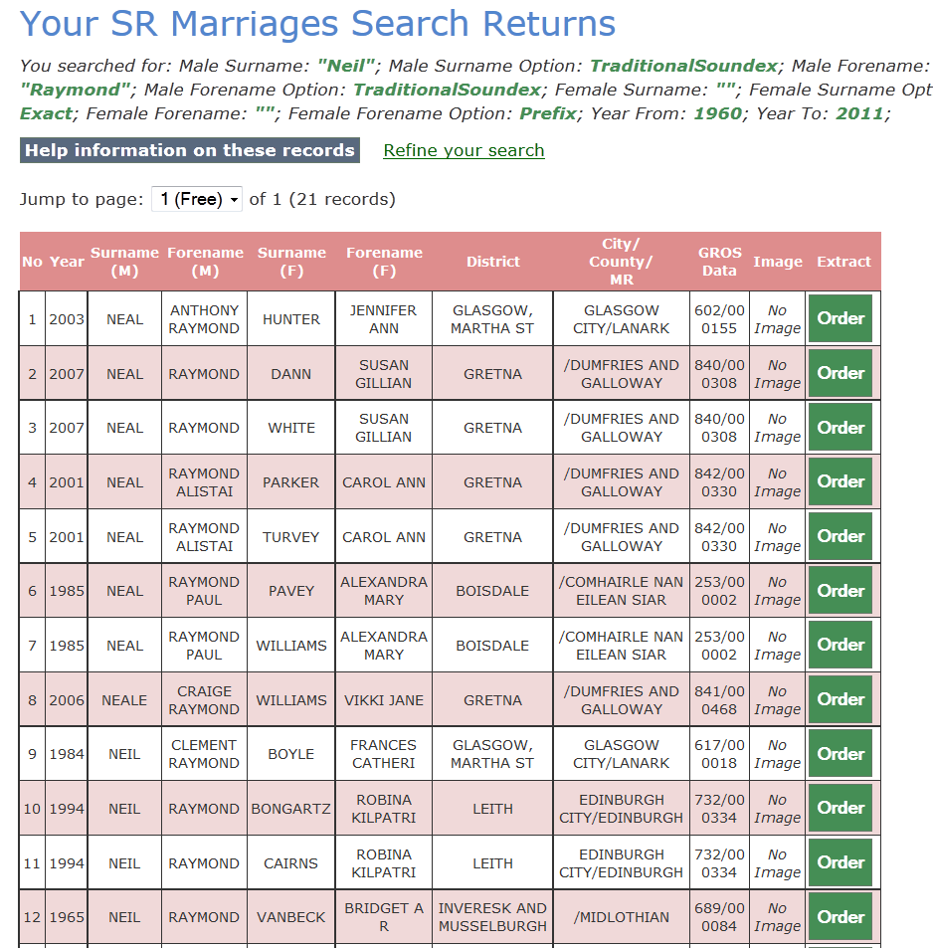
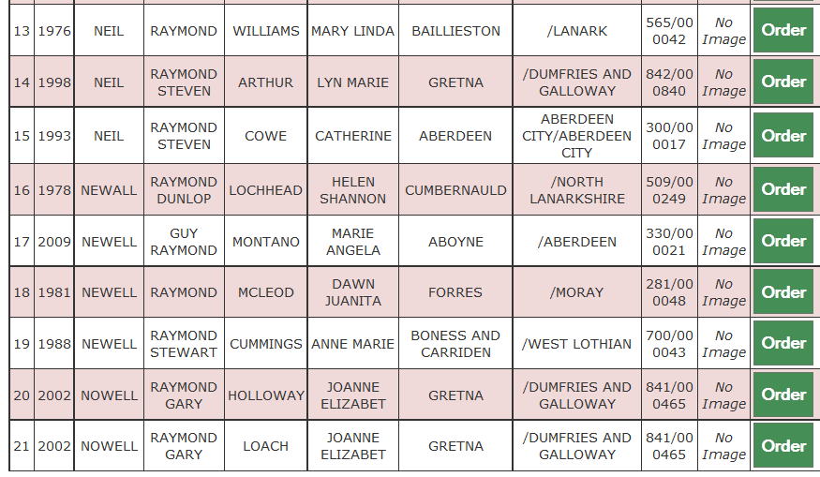
No | Year | Surname  (M) | Forename  (M) | Surname  (F) | Forename  (F) | District | City/  County/  MR | GROS  Data
1 | 2003 | NEAL | ANTHONY RAYMOND | HUNTER | JENNIFER ANN | GLASGOW, MARTHA ST | GLASGOW CITY/LANARK | 602/00 0155
2 | 2007 | NEAL | RAYMOND | DANN | SUSAN GILLIAN | GRETNA | /DUMFRIES AND GALLOWAY | 840/00 0308
3 | 2007 | NEAL | RAYMOND | WHITE | SUSAN GILLIAN | GRETNA | /DUMFRIES AND GALLOWAY | 840/00 0308
4 | 2001 | NEAL | RAYMOND ALISTAI | PARKER | CAROL ANN | GRETNA | /DUMFRIES AND GALLOWAY | 842/00 0330
5 | 2001 | NEAL | RAYMOND ALISTAI | TURVEY | CAROL ANN | GRETNA | /DUMFRIES AND GALLOWAY | 842/00 0330
6 | 1985 | NEAL | RAYMOND PAUL | PAVEY | ALEXANDRA MARY | BOISDALE | /COMHAIRLE NAN EILEAN SIAR | 253/00 0002
7 | 1985 | NEAL | RAYMOND PAUL | WILLIAMS | ALEXANDRA MARY | BOISDALE | /COMHAIRLE NAN EILEAN SIAR | 253/00 0002
8 | 2006 | NEALE | CRAIGE RAYMOND | WILLIAMS | VIKKI JANE | GRETNA | /DUMFRIES AND GALLOWAY | 841/00 0468
9 | 1984 | NEIL | CLEMENT RAYMOND | BOYLE | FRANCES CATHERI | GLASGOW, MARTHA ST | GLASGOW CITY/LANARK | 617/00 0018
10 | 1994 | NEIL | RAYMOND | BONGARTZ | ROBINA KILPATRI | LEITH | EDINBURGH CITY/EDINBURGH | 732/00 0334
11 | 1994 | NEIL | RAYMOND | CAIRNS | ROBINA KILPATRI | LEITH | EDINBURGH CITY/EDINBURGH | 732/00 0334
12 | 1965 | NEIL | RAYMOND | VANBECK | BRIDGET A R | INVERESK AND MUSSELBURGH | /MIDLOTHIAN | 689/00 0084
13 | 1976 | NEIL | RAYMOND | WILLIAMS | MARY LINDA | BAILLIESTON | /LANARK | 565/00 0042
14 | 1998 | NEIL | RAYMOND STEVEN | ARTHUR | LYN MARIE | GRETNA | /DUMFRIES AND GALLOWAY | 842/00 0840
15 | 1993 | NEIL | RAYMOND STEVEN | COWE | CATHERINE | ABERDEEN | ABERDEEN CITY/ABERDEEN CITY | 300/00 0017
16 | 1978 | NEWALL | RAYMOND DUNLOP | LOCHHEAD | HELEN SHANNON | CUMBERNAULD | /NORTH LANARKSHIRE | 509/00 0249
17 | 2009 | NEWELL | GUY RAYMOND | MONTANO | MARIE ANGELA | ABOYNE | /ABERDEEN | 330/00 0021
18 | 1981 | NEWELL | RAYMOND | MCLEOD | DAWN JUANITA | FORRES | /MORAY | 281/00 0048
19 | 1988 | NEWELL | RAYMOND STEWART | CUMMINGS | ANNE MARIE | BONESS AND CARRIDEN | /WEST LOTHIAN | 700/00 0043
20 | 2002 | NOWELL | RAYMOND GARY | HOLLOWAY | JOANNE ELIZABET | GRETNA | /DUMFRIES AND GALLOWAY | 841/00 0465
21 | 2002 | NOWELL | RAYMOND GARY | LOACH | JOANNE ELIZABET | GRETNA | /DUMFRIES AND GALLOWAY | 841/00 0465

