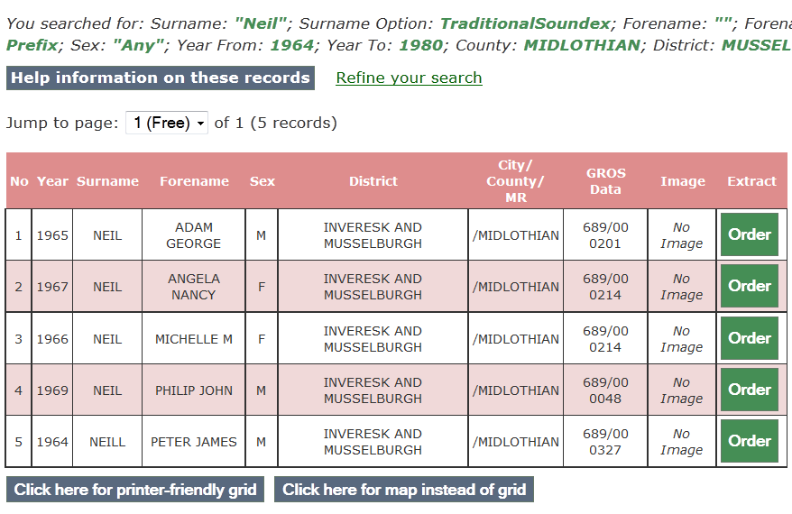 Your SR Births Search Returns
You searched for: Surname: "Neil"; Surname Option: TraditionalSoundex; Forename: ""; Forename Option: Prefix; Sex: "Any"; Year From: 1964; Year To: 1980; County: MIDLOTHIAN; District: MUSSELBURGH;
Refine your search
Jump to page: of 1 (5 records)
No | Year | Surname | Forename | Sex | District | City/  County/  MR | GROS  Data
1 | 1965 | NEIL | ADAM GEORGE | M | INVERESK AND MUSSELBURGH | /MIDLOTHIAN | 689/00 0201
2 | 1967 | NEIL | ANGELA NANCY | F | INVERESK AND MUSSELBURGH | /MIDLOTHIAN | 689/00 0214
3 | 1966 | NEIL | MICHELLE M | F | INVERESK AND MUSSELBURGH | /MIDLOTHIAN | 689/00 0214
4 | 1969 | NEIL | PHILIP JOHN | M | INVERESK AND MUSSELBURGH | /MIDLOTHIAN | 689/00 0048
5 | 1964 | NEILL | PETER JAMES | M | INVERESK AND MUSSELBURGH | /MIDLOTHIAN | 689/00 0327

