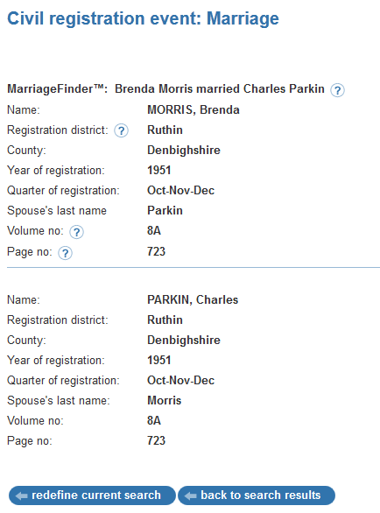


Civil Registration event: Marriage
Print Close
MarriageFinder: Brenda Morris married Charles Parkin
Name: | MORRIS, Brenda
Registration district: | Ruthin
County: | Denbighshire
Year of registration: | 1951
Quarter of registration: | Oct-Nov-Dec
Spouse's last name: | Parkin
Volume no: | 8A
Page no: | 723
Name: | PARKIN, Charles
Registration district: | Ruthin
County: | Denbighshire
Year of registration: | 1951
Quarter of registration: | Oct-Nov-Dec
Spouse's last name: | Morris
Volume no: | 8A
Page no: | 723

