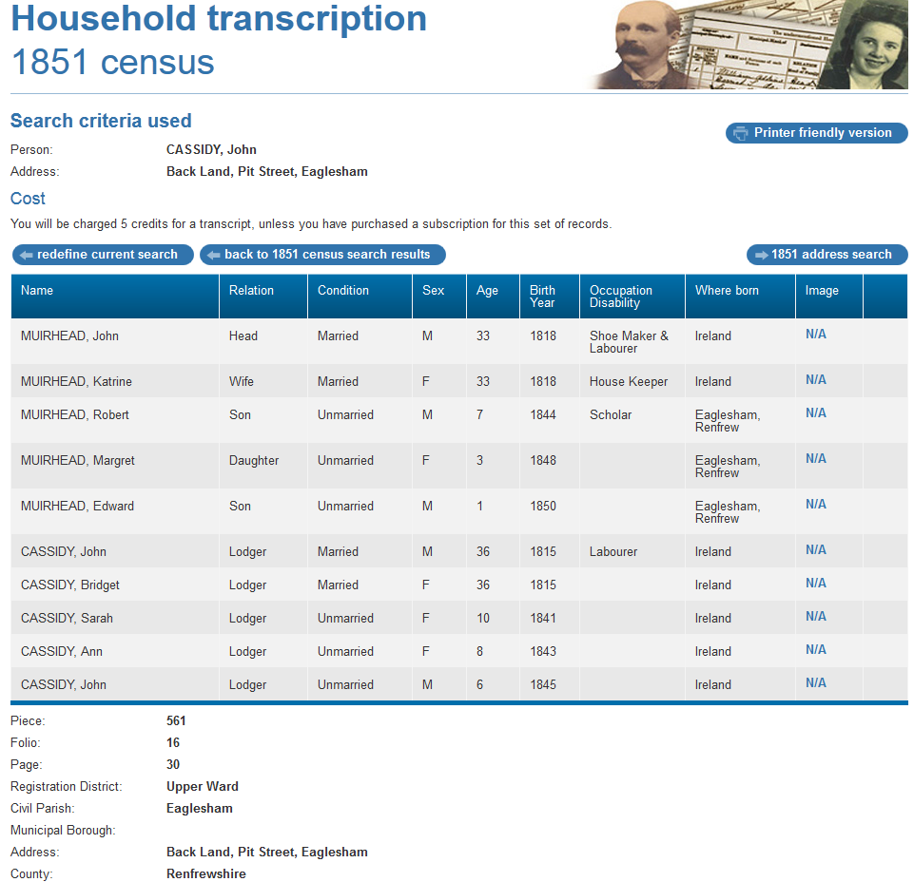

1851 census transcription details for: Back Land, Pit Street, Eaglesham
Print Close
National Archive Reference:
RG number:
Piece: | 561
Folio: | 16
Page: | 30
Reg. District: | Upper Ward
Sub District:
Parish: | Eaglesham
Enum. District: | 6
Ecclesiastical District:
City/Municipal Borough:
Address: | Back Land, Pit Street, Eaglesham
County: | Renfrewshire

Name | Relation | Condition | Sex | Age | Birth Year | Occupation , Disability | Where Born
MUIRHEAD, John | Head | Married | M | 33 | 1818 | Shoe Maker & Labourer | Ireland
MUIRHEAD, Katrine | Wife | Married | F | 33 | 1818 | House Keeper | Ireland
MUIRHEAD, Robert | Son | Unmarried | M | 7 | 1844 | Scholar | Eaglesham, Renfrew
MUIRHEAD, Margret | Daughter | Unmarried | F | 3 | 1848 |  | Eaglesham, Renfrew
MUIRHEAD, Edward | Son | Unmarried | M | 1 | 1850 |  | Eaglesham, Renfrew
CASSIDY, John | Lodger | Married | M | 36 | 1815 | Labourer | Ireland
CASSIDY, Bridget | Lodger | Married | F | 36 | 1815 |  | Ireland
CASSIDY, Sarah | Lodger | Unmarried | F | 10 | 1841 |  | Ireland
CASSIDY, Ann | Lodger | Unmarried | F | 8 | 1843 |  | Ireland
CASSIDY, John | Lodger | Unmarried | M | 6 | 1845 |  | Ireland

© Reproduced courtesy of The National Archives, London, England

The following from Scotland's People
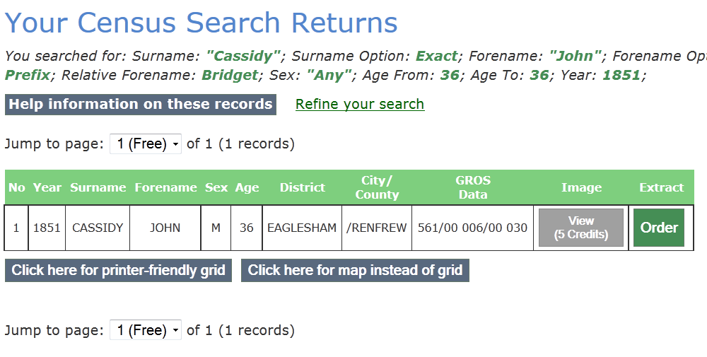

Your Census Search Returns
You searched for: Surname: "Cassidy"; Surname Option: Exact; Forename: "John"; Forename Option: Prefix; Relative Forename: Bridget; Sex: "Any"; Age From: 36; Age To: 36; Year: 1851;
Refine your search
Jump to page: of 1 (1 records)
No | Year | Surname | Forename | Sex | Age | District | City/  County | GROS  Data
1 | 1851 | CASSIDY | JOHN | M | 36 | EAGLESHAM | /RENFREW | 561/00 006/00 030

