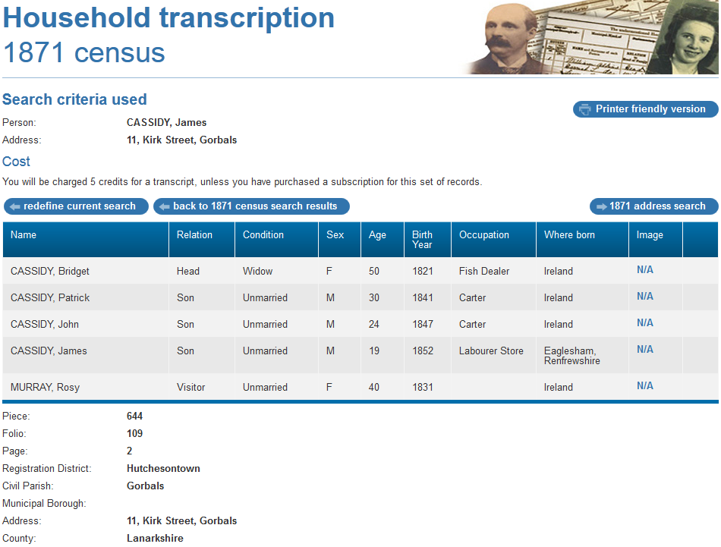



1871 census transcription details for: 11, Kirk Street, Gorbals
Print Close
National Archive Reference:
RG number: | RG10
Piece: | 644
Folio: | 109
Page: | 2
Reg. District: | Hutchesontown
Sub District:
Parish: | Gorbals
Enum. District: | 109
Ecclesiastical District:
City/Municipal Borough:
Address: | 11, Kirk Street, Gorbals
County: | Lanarkshire

Name | Relation | Condition | Sex | Age | Birth Year | Occupation | Where Born
CASSIDY, Bridget | Head | Widow | F | 50 | 1821 | Fish Dealer | Ireland
CASSIDY, Patrick | Son | Unmarried | M | 30 | 1841 | Carter | Ireland
CASSIDY, John | Son | Unmarried | M | 24 | 1847 | Carter | Ireland
CASSIDY, James | Son | Unmarried | M | 19 | 1852 | Labourer Store | Eaglesham, Renfrewshire
MURRAY, Rosy | Visitor | Unmarried | F | 40 | 1831 |  | Ireland

