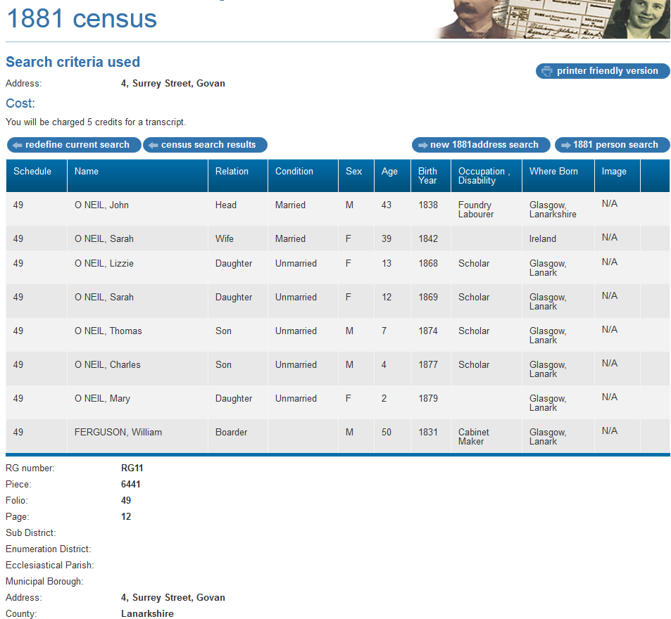
1881 Census transcription details for: 4, Surrey Street, Govan
National Archive Reference:
RG number | RG11
Piece: | 6441
Folio: | 49
Page: | 12
Reg. District: | Gorbals
Sub District:
Parish: | Govan
Enum. District:
Ecclesiastical District:
City/Municipal Borough:
Address: | 4, Surrey Street, Govan
County: | Lanarkshire

Name | Relation | Condition | Sex | Age | Birth Year | Occupation , Disability | Where Born
O NEIL, John | Head | Married | M | 43 | 1838 | Foundry Labourer | Glasgow, Lanarkshire
O NEIL, Sarah | Wife | Married | F | 39 | 1842 |  | Ireland
O NEIL, Lizzie | Daughter | Unmarried | F | 13 | 1868 | Scholar | Glasgow, Lanark
O NEIL, Sarah | Daughter | Unmarried | F | 12 | 1869 | Scholar | Glasgow, Lanark
O NEIL, Thomas | Son | Unmarried | M | 7 | 1874 | Scholar | Glasgow, Lanark
O NEIL, Charles | Son | Unmarried | M | 4 | 1877 | Scholar | Glasgow, Lanark
O NEIL, Mary | Daughter | Unmarried | F | 2 | 1879 |  | Glasgow, Lanark
FERGUSON, William | Boarder |  | M | 50 | 1831 | Cabinet Maker | Glasgow, Lanark

