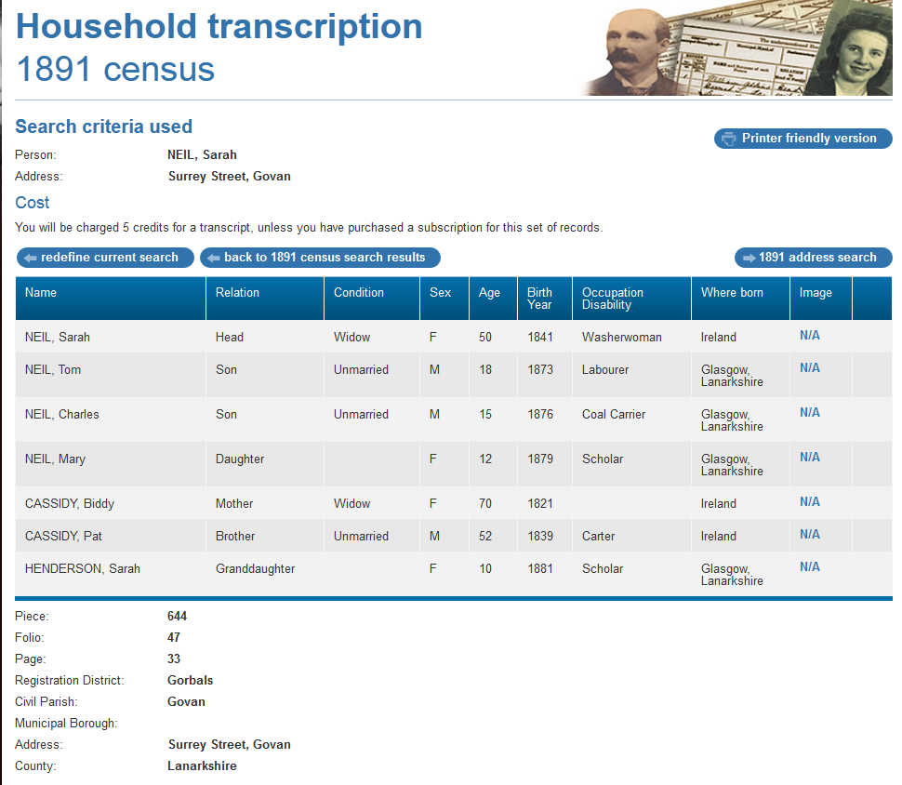

1891 census transcription details for: Surrey Street, Govan
National Archive Reference:
RG number: | RG12
Piece: | 644
Folio: | 47
Page: | 33
Reg. District: | Gorbals
Sub District:
Parish: | Govan
Enum. District: | 47
Ecclesiastical District:
City/Municipal Borough:
Address: | Surrey Street, Govan
County: | Lanarkshire

Name | Relation | Condition | Sex | Age | Birth Year | Occupation , Disability | Where Born
NEIL, Sarah | Head | Widow | F | 50 | 1841 | Washerwoman | Ireland
NEIL, Tom | Son | Unmarried | M | 18 | 1873 | Labourer | Glasgow, Lanarkshire
NEIL, Charles | Son | Unmarried | M | 15 | 1876 | Coal Carrier | Glasgow, Lanarkshire
NEIL, Mary | Daughter |  | F | 12 | 1879 | Scholar | Glasgow, Lanarkshire
CASSIDY, Biddy | Mother | Widow | F | 70 | 1821 |  | Ireland
CASSIDY, Pat | Brother | Unmarried | M | 52 | 1839 | Carter | Ireland
HENDERSON, Sarah | Granddaughter |  | F | 10 | 1881 | Scholar | Glasgow, Lanarkshire

