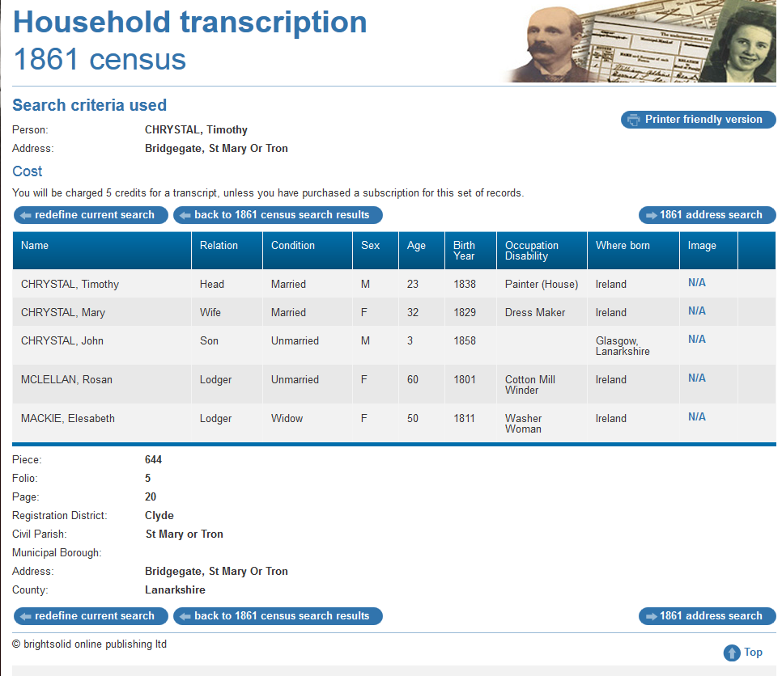

1861 census transcription details for: Bridgegate, St Mary Or Tron
Print Close
National Archive Reference:
RG number: | RG09
Piece: | 644
Folio: | 5
Page: | 20
Reg. District: | Clyde
Sub District:
Parish: | St Mary or Tron
Enum. District: | 20
Ecclesiastical District:
City/Municipal Borough:
Address: | Bridgegate, St Mary Or Tron
County: | Lanarkshire

Name | Relation | Condition | Sex | Age | Birth Year | Occupation , Disability | Where Born
CHRYSTAL, Timothy | Head | Married | M | 23 | 1838 | Painter (House) | Ireland
CHRYSTAL, Mary | Wife | Married | F | 32 | 1829 | Dress Maker | Ireland
CHRYSTAL, John | Son | Unmarried | M | 3 | 1858 |  | Glasgow, Lanarkshire
MCLELLAN, Rosan | Lodger | Unmarried | F | 60 | 1801 | Cotton Mill Winder | Ireland
MACKIE, Elesabeth | Lodger | Widow | F | 50 | 1811 | Washer Woman | Ireland

