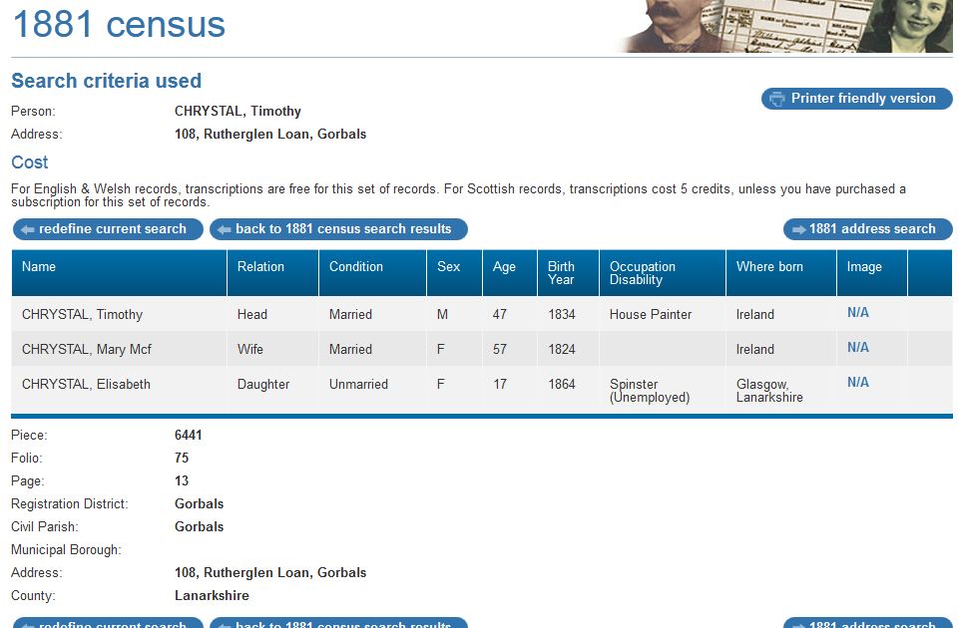

1881 census transcription details for: 108, Rutherglen Loan, Gorbals
RG number: | RG11
Piece: | 6441
Folio: | 75
Page: | 13
Reg. District: | Gorbals
Sub District:
Parish: | Gorbals
Enum. District:
Ecclesiastical District:
City/Municipal Borough:
Address: | 108, Rutherglen Loan, Gorbals
County: | Lanarkshire

Name | Relation | Condition | Sex | Age | Birth Year | Occupation , Disability | Where Born
CHRYSTAL, Timothy | Head | Married | M | 47 | 1834 | House Painter | Ireland
CHRYSTAL, Mary Mcf | Wife | Married | F | 57 | 1824 |  | Ireland
CHRYSTAL, Elisabeth | Daughter | Unmarried | F | 17 | 1864 | Spinster (Unemployed) | Glasgow, Lanarkshire

