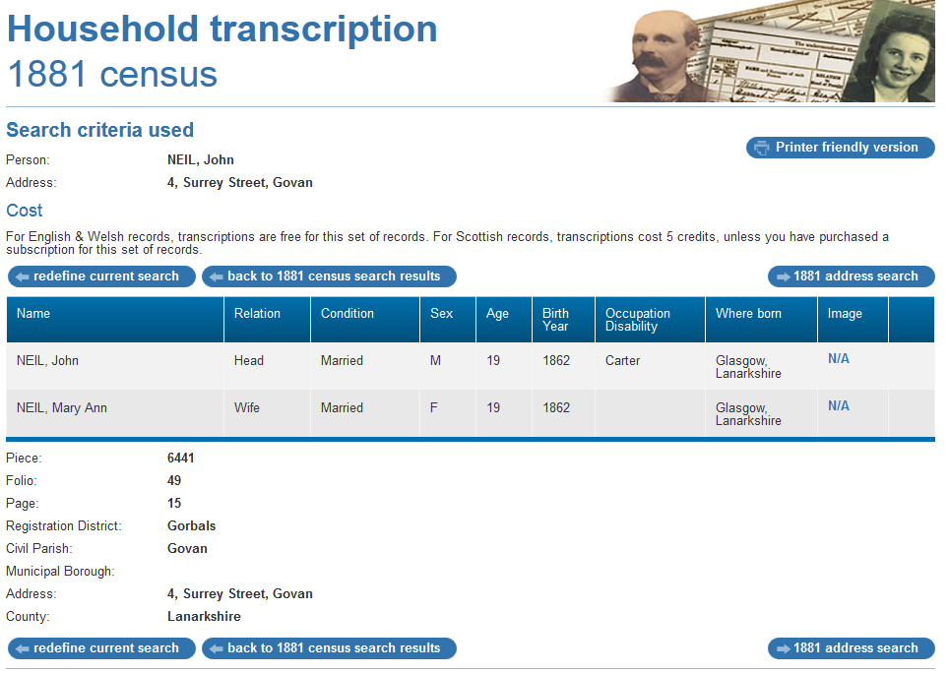

1881 census transcription details for: 4, Surrey Street, Govan
RG number: | RG11
Piece: | 6441
Folio: | 49
Page: | 15
Reg. District: | Gorbals
Sub District:
Parish: | Govan
Enum. District:
Ecclesiastical District:
City/Municipal Borough:
Address: | 4, Surrey Street, Govan
County: | Lanarkshire

Name | Relation | Condition | Sex | Age | Birth Year | Occupation , Disability | Where Born
NEIL, John | Head | Married | M | 19 | 1862 | Carter | Glasgow, Lanarkshire
NEIL, Mary Ann | Wife | Married | F | 19 | 1862 |  | Glasgow, Lanarkshire

