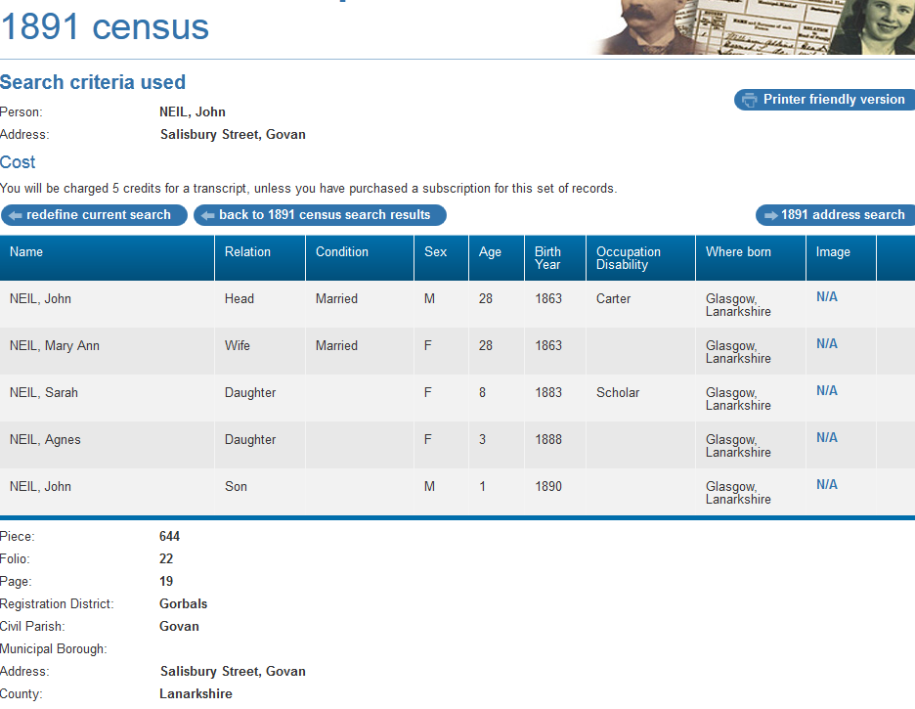

1891 census transcription details for: Salisbury Street, Govan
RG number: | RG12
Piece: | 644
Folio: | 22
Page: | 19
Reg. District: | Gorbals
Sub District:
Parish: | Govan
Enum. District: | 22
Ecclesiastical District:
City/Municipal Borough:
Address: | Salisbury Street, Govan
County: | Lanarkshire

Name | Relation | Condition | Sex | Age | Birth Year | Occupation , Disability | Where Born
NEIL, John | Head | Married | M | 28 | 1863 | Carter | Glasgow, Lanarkshire
NEIL, Mary Ann | Wife | Married | F | 28 | 1863 |  | Glasgow, Lanarkshire
NEIL, Sarah | Daughter |  | F | 8 | 1883 | Scholar | Glasgow, Lanarkshire
NEIL, Agnes | Daughter |  | F | 3 | 1888 |  | Glasgow, Lanarkshire
NEIL, John | Son |  | M | 1 | 1890 |  | Glasgow, Lanarkshire

