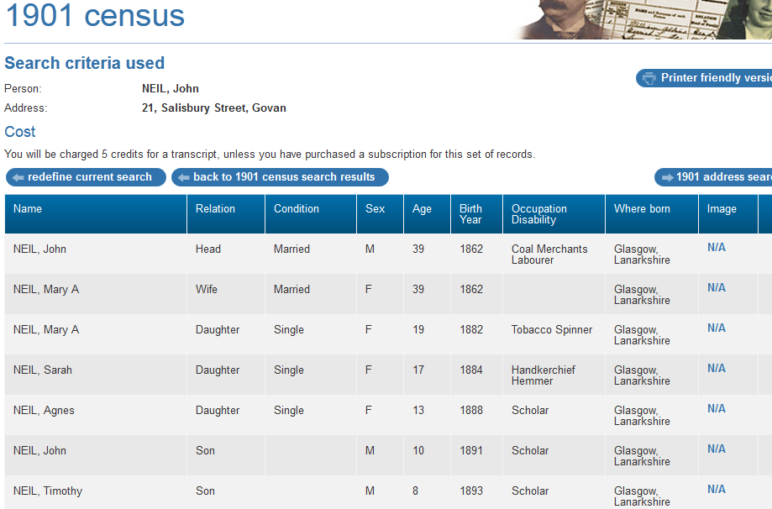
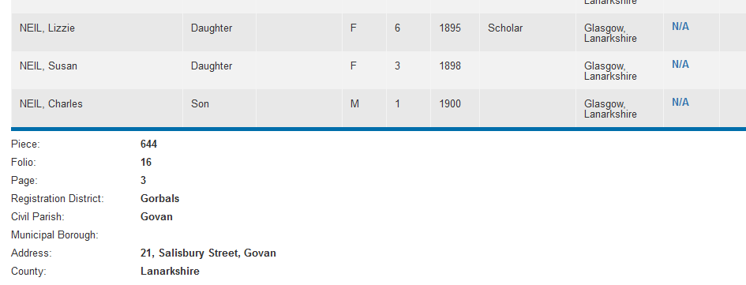

1901 census transcription details for: 21, Salisbury Street, Govan
Print Close
National Archive Reference:
RG number: | RG13
Piece: | 644
Folio: | 16
Page: | 3
Reg. District: | Gorbals
Sub District:
Parish: | Govan
Enum. District:
Ecclesiastical District: | Govan
City/Municipal Borough:
Address: | 21, Salisbury Street, Govan
County: | Lanarkshire

Name | Relation | Condition | Sex | Age | Birth Year | Occupation , Disability | Where Born
NEIL, John | Head | Married | M | 39 | 1862 | Coal Merchants Labourer | Glasgow, Lanarkshire
NEIL, Mary A | Wife | Married | F | 39 | 1862 |  | Glasgow, Lanarkshire
NEIL, Mary A | Daughter | Single | F | 19 | 1882 | Tobacco Spinner | Glasgow, Lanarkshire
NEIL, Sarah | Daughter | Single | F | 17 | 1884 | Handkerchief Hemmer | Glasgow, Lanarkshire
NEIL, Agnes | Daughter | Single | F | 13 | 1888 | Scholar | Glasgow, Lanarkshire
NEIL, John | Son |  | M | 10 | 1891 | Scholar | Glasgow, Lanarkshire
NEIL, Timothy | Son |  | M | 8 | 1893 | Scholar | Glasgow, Lanarkshire
NEIL, Lizzie | Daughter |  | F | 6 | 1895 | Scholar | Glasgow, Lanarkshire
NEIL, Susan | Daughter |  | F | 3 | 1898 |  | Glasgow, Lanarkshire
NEIL, Charles | Son |  | M | 1 | 1900 |  | Glasgow, Lanarkshire

