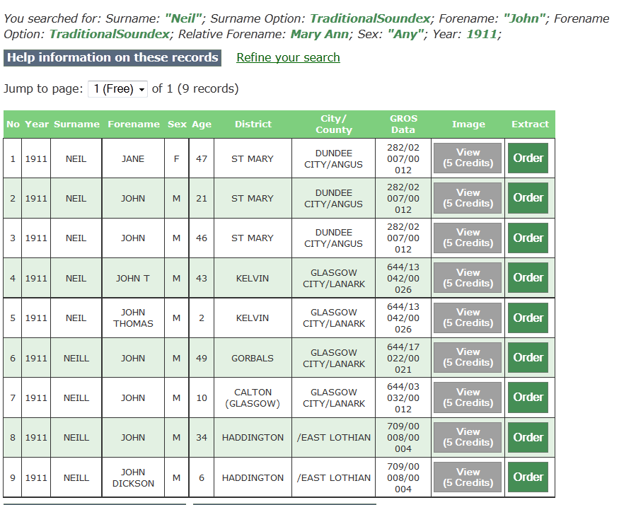

Your Census Search Returns
You searched for: Surname: "Neil"; Surname Option: TraditionalSoundex; Forename: "John"; Forename Option: TraditionalSoundex; Relative Forename: Mary Ann; Sex: "Any"; Year: 1911;
Refine your search
Jump to page: of 1 (9 records)
No | Year | Surname | Forename | Sex | Age | District | City/  County | GROS  Data
1 | 1911 | NEIL | JANE | F | 47 | ST MARY | DUNDEE CITY/ANGUS | 282/02 007/00 012
2 | 1911 | NEIL | JOHN | M | 21 | ST MARY | DUNDEE CITY/ANGUS | 282/02 007/00 012
3 | 1911 | NEIL | JOHN | M | 46 | ST MARY | DUNDEE CITY/ANGUS | 282/02 007/00 012
4 | 1911 | NEIL | JOHN T | M | 43 | KELVIN | GLASGOW CITY/LANARK | 644/13 042/00 026
5 | 1911 | NEIL | JOHN THOMAS | M | 2 | KELVIN | GLASGOW CITY/LANARK | 644/13 042/00 026
6 | 1911 | NEILL | JOHN | M | 49 | GORBALS | GLASGOW CITY/LANARK | 644/17 022/00 021
7 | 1911 | NEILL | JOHN | M | 10 | CALTON (GLASGOW) | GLASGOW CITY/LANARK | 644/03 032/00 012
8 | 1911 | NEILL | JOHN | M | 34 | HADDINGTON | /EAST LOTHIAN | 709/00 008/00 004
9 | 1911 | NEILL | JOHN DICKSON | M | 6 | HADDINGTON | /EAST LOTHIAN | 709/00 008/00 004

