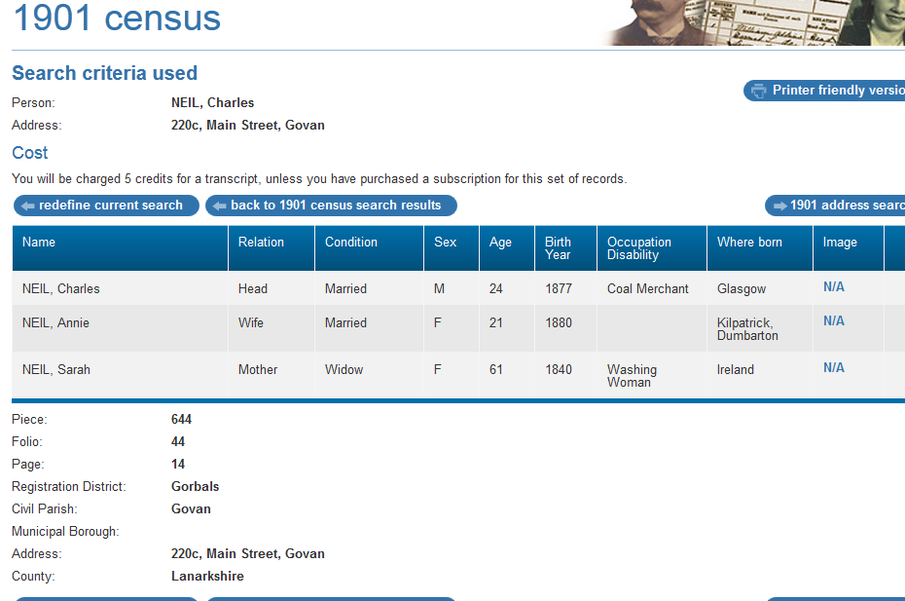

1901 census transcription details for: 220c, Main Street, Govan
National Archive Reference:
RG number: | RG13
Piece: | 644
Folio: | 44
Page: | 14
Reg. District: | Gorbals
Sub District:
Parish: | Govan
Enum. District:
Ecclesiastical District: | Gorbals
City/Municipal Borough:
Address: | 220c, Main Street, Govan
County: | Lanarkshire

Name | Relation | Condition | Sex | Age | Birth Year | Occupation , Disability | Where Born
NEIL, Charles | Head | Married | M | 24 | 1877 | Coal Merchant | Glasgow
NEIL, Annie | Wife | Married | F | 21 | 1880 |  | Kilpatrick, Dumbarton
NEIL, Sarah | Mother | Widow | F | 61 | 1840 | Washing Woman | Ireland

