Research into Thomas Neil who died of cholera in 1854
I have been looking for the death of a Thomas Neil or any other information about him. He was the father of John Neill who was born 14th April 1836 and baptised 4th July 1836, the lawful son of Thomas Neill and Agnes Feran. His baptism was recorded St. Andrew's Cathedral in Clyde Street and the entry was found for me by Mrs Elizabeth Smith of the Glasgow and West of Scotland FHS.
Many years passed with no further movement of either Agnes or Thomas until one day when I came across postings by Matt Neil on the members forum section of the Association of O'Neill Clans web site that traced his ancestry back to our common ancestor John Neil and his wife, Sarah Cassidy.
"This is some of the info i've gotten from my father and his side of the family. I'm hoping more info will become available from my fathers side but i think the well is near enough dry and i'm skint for the foreseeable future so no ancestry/genealogy sites for me :(.
Me - Matthew James Neil, DOB 05.08.1991, Glasgow.
Father - Gordon Neil, DOB 29.08.1957, Glasgow
Mother Linda Fee (Brueton) DOB 28.01.1956 Glasgow.
Grandfather - James McCue Neil, DOB 01.02.19232, Glasgow Gorbals.
Grandmother - Martha Mary Neil (McLean) 02.01.1934, Glasgow Springburn, DOD 11.12.1992.
Great Grandfather - Charles Neil, DOB 30.04.1899 DOD - 1934, Glasgow (i'm assuming). Married Marion McMillan Neil (Barrat)
Great Grandmother - Marion McMillan Neil (Barrat), DOB 17.12 1900. no DOD.
Marion's Parents :
Richard Barrat born Ireland 1857. Married Flora Morrison 04.11.1898.
Flora Morrison born Scotland 1862. Married Richard Barrat 04.11.1898, DOD 14.09.1909.
Richard Barrat's Parents : Patrick Barrat born Ireland 1821, Bridget Haggerty 1827.
Flora Morrisons Parents : David Morrison and Agnes Taylor.
Great Great Grandfather - John Neil, Born 1860 Glasgow. Married Mary Anne 02.10.1880. Both 19.
Great Great Grandmother - Mary Anne Neil (Chrystal) born 1860, Glasgow. Married John Neil 02.10.1880. Both 19.
Mary Anne Chrystal's Parents Timothy Chrystal and Mary McFillan.
Great Great Great Grandfather - John Neil (no DOB). Married Sarah Cassidy 1860 in Glasgow.
Great Great Great Grandmother - Sarah Cassidy (no DOB). Married John Neil 1860 in Glasgow.
More to come hopefully. Could anyone per chance help me with my stuff ? it'd be much appreciated."
from http://www.oneillclans.com/forum/4-genealogy/1659-neil-line-my-line.html
It was clear from this that he and I shared the John Neil & Sarah Cassidy connection but he did not know any more ; or at least not until he later posted suggesting that he had discovered Thomas Neil's death in Glasgow. "
"Thomas Neil born 1793 Donegal, Ireland. Died aged 60 of Cholera, Glasgow. So i've found my irish ancestor :D."
from http://www.oneillclans.com/forum/4-genealogy/1659-neil-line-my-line.html
Sometime later I looked in the records for this death and I found the following :
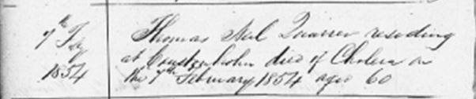
The entry reads
"7th February 1854 (registered) Thomas Neil Quarrier residing at Coustonholm died of Cholera on the 7th February 1854 aged 60"
The curious thing about this is that whilst it does mention the death of Thomas, it does not mention his place of birth. Since Matthew Neil had said that he was born in Donegal, I tried to contact him to try to clarify where this piece of information came from. I eventually managed to contact him (with some difficulty) but he could not enlighten me further as this information had been collected by his father and although I asked him to get his father to contact me if he was interested in discussing this, I did not hear anything more so it remained a mystery. If the death registration did not mention a place of birth, how did Matt know it was Donegal ? At the time I wrote "Since we cannot find out the source of this information it is not really possible to verify it". The date of birth is also a problem. If this is the same Thomas he would have been born about 1794 and therefore about forty years old at the birth of John Neill who was born 14th April 1836 and was baptised 4th July 1836.
This whole issue went on the back burner for another few years until I heard from Elizabeth Smith - somewhat out of the blue - as a result of renewing my FHS membership (she had become the membership secretary and had noticed an email from me) and emailed saying hello. I updated her on the Matthew Neil information and on the mystery of the Thomas Neil who had died of cholera in 1854. She replied saying that "we have recently completed photographing and transcribing the stones ...at Cathcart Churchyard" and she had found a gravestone that probably referred to this Thomas Neil. She transcribed the gravestone a follows :

MARGARET MURRAY Sacred to the memory of her husband THOMAS NEIL, quarrier and stone merchant, who died 7th February 1854
and their family,
JAMES, died 8th November 1839,
MARGARET died 2nd July 1844,
ROBERT died at Rodney Downs, Queensland, 17th December 1874,
THOMAS died 10th May 1886.
The above MARGARET MURRAY died 6th July 1888,
their daughter AGNES NEIL died 2nd April 1917,
their daughter JANET NEIL died 2nd September 1920.

This was clearly the Thomas Neil, "Quarrier residing at Coustonholm died of Cholera on the 7th February 1854 aged 60"of the Cathcard register so it was obvious, even if this was not "my" Thomas that I should try to find more about this family since the gravestone gave us so much information to start with. The first thing we looked at was for the death of Margaret Neil nee Murray and the Statutory Register of Deaths turned up the following :

Your SR Deaths Search Returns
You searched for: Surname: "Neil"; Surname Option: Fuzzy; Forename: "Margaret"; Forename Option: Prefix; Sex: "Female"; Year From: 1888; Year To: 1888;
No | Year | Surname | Forename | Mother's | Other | S | A | District | City/ |  | GROS
No | Year | /Maiden Name | Forename | Surname | Surnames | e | g | District | County/ |  | Data
No | Year |  | Forename |  |  | x | e | District | MR
1 | 1888 | NEIL | MARGARET |  |  | F | 0 | ANDERSTON | GLASGOW CITY/LANARK |  | 644/10 0212
2 | 1888 | NEIL | MARGARET |  | BROWN | F | 68 | FALKIRK BURGH | /STIRLING |  | 479/01 0002
3 | 1888 | NEIL | MARGARET |  | SHARP | F | 41 | WILTON | /ROXBURGH |  | 810/00 0103
4 | 1888 | NEIL | MARGARET |  | MURRAY | F | 85 | GORBALS | GLASGOW CITY/LANARK |  | 644/12 0476
5 | 1888 | NEIL | MARGARET |  | DOUGLAS | F | 25 | KELVIN | GLASGOW CITY/LANARK |  | 644/09 0785
6 | 1888 | NEIL | MARGARET |  | STEWART | F | 38 | KINNING PARK | GLASGOW CITY/LANARK |  | 644/14 0433
7 | 1888 | NEILL | MARGARET |  | BROWN | F | 33 | FALKIRK LANDWARD | /STIRLING |  | 479/02 0139
8 | 1888 | NEILL | MARGARET |  | HAMILL | F | 0 | STRANRAER | /WIGTOWN |  | 899/00 0048
9 | 1888 | NEILL | MARGARET |  | CARR | F | 41 | ST GILES | EDINBURGH CITY/MIDLOTHIAN |  | 685/04 0021
10 | 1888 | O'NEIL | MARGARET |  |  | F | 1 | ST GILES | EDINBURGH CITY/MIDLOTHIAN |  | 685/04 0640
11 | 1888 | O'NEIL | MARGARET |  | SMITH | F | 24 | ST MARY | DUNDEE CITY/ANGUS |  | 282/02 0450
12 | 1888 | O'NEIL | MARGARET |  | SCANLAN | F | 61 | HUTCHESONTOWN | GLASGOW CITY/LANARK |  | 644/11 0476

Our Margaret seemed quite likely so be obtained an image of the entry :
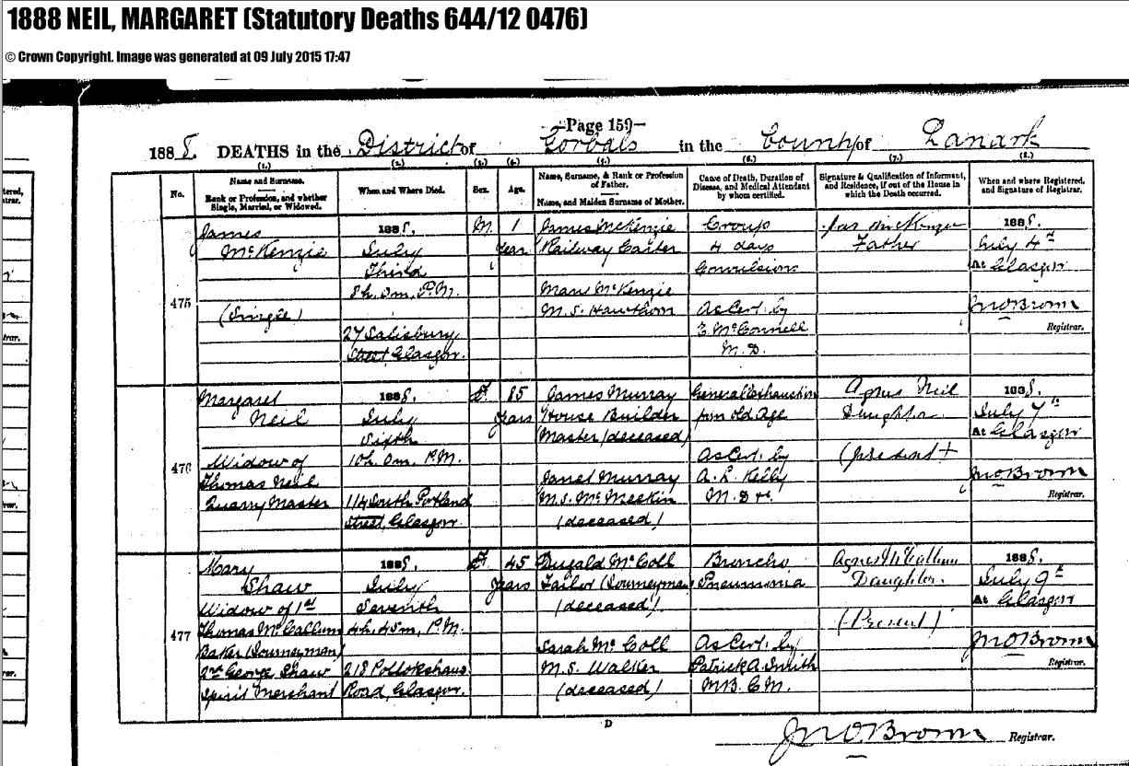
The information gleaned was as follows :
Margaret Neil, widow of Thomas Neil, Quarry Master died 10pm 6th of July 1888 at 114 South Portland Street, Glasgow. Her father was James Murray, House Builder (Master deceased). Her mother was Janet Murray ms Mc. Meekin (?) (deceased). She died of General Exhaustion from Old Age as certified by A. R. Kelly M Dr. The informant was Agnes Neil, daughter, Present +.The death was registered 7th July 1888 at Glasgow.
This Margaret Murray was obviously the correct one and she was born circa 1803 so we thought that she probably married Thomas Neil after about 1820
The only likely Thomas Neil marrying a Margaret Murray I could find was one that took place in Sorn, Ayr and dated 22 June 1827
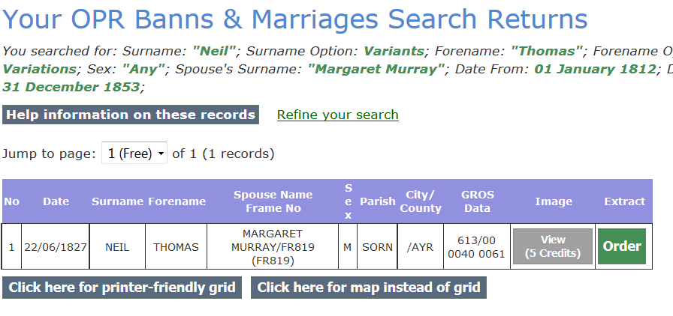
I looked up the marriage registration in the parish registers online but they merely confirmed the above saying "Thomas Neil and Margt. Murray both in this Parish after being duly proclaimed here in order to marriage, were married 22d. June 1827" (18th was written but scored out) The parish was Sorn and the County was Ayr. So nothing was learned from looking at this entry that we hadn't already got from the index entry.
Moving on, we decided to look for children born to this couple and a look at the LDS web site turned up the following children that seem to be connected to these parents :
Name | born | christ | where
Janet Neil | 24 April 1828 | 4 May 1828 | Sorn, Ayrshire, Scotland
Elizabeth Neil | 6 April 1830 | 18 April 1830 | Sorn, Ayrshire, Scotland
Robert Neil | 19 August 1832 | 2 September 1832 | Sorn, Ayrshire, Scotland
Agnes Neil | 25 July 1834 | 10 August 1834 | Sorn, Ayrshire, Scotland

The only other possible fits with parents of the same age were :
Name | born | christ | where
Harriet Neil | 6 September 1842 |  | Eastwood, Renfrewshire
Thomas Neil | 10 November 1845 |  | Eastwood, Renfrewshire

We found some other outliers with the same parental names but these were obviously not "mine"
Name | born | christ | where
Catherine Neil | 13 January 1874 |  | Jedburgh, Roxburgh | mother given as Margaret Neil
Isabella Neil | 31 August 1881 |  | Wilton, Roxburgh | mother given as Margaret Murray Neil
William Neil | 20 October 1883 |  | Roxburghshire, Scotland | died Vancouver 8 January 1979

The gravestone that Elizabeth Smith sent mentioned a James, a Margaret, a Robert, a Thomas, an Agnes and a Janet. So we were still missing some births from the LDS returns. They did not mention James, Margaret, or Thomas. The Thomas born 10 November 1845 could be the missing Thomas but that seemed like a long gap between Agnes in 1834 and this Thomas in 1845. I thought that probably the best way to find out about these gaps between children was to try to find the family in the census taken a couple of years before Thomas senior died - the 1851 census.

I did the following search
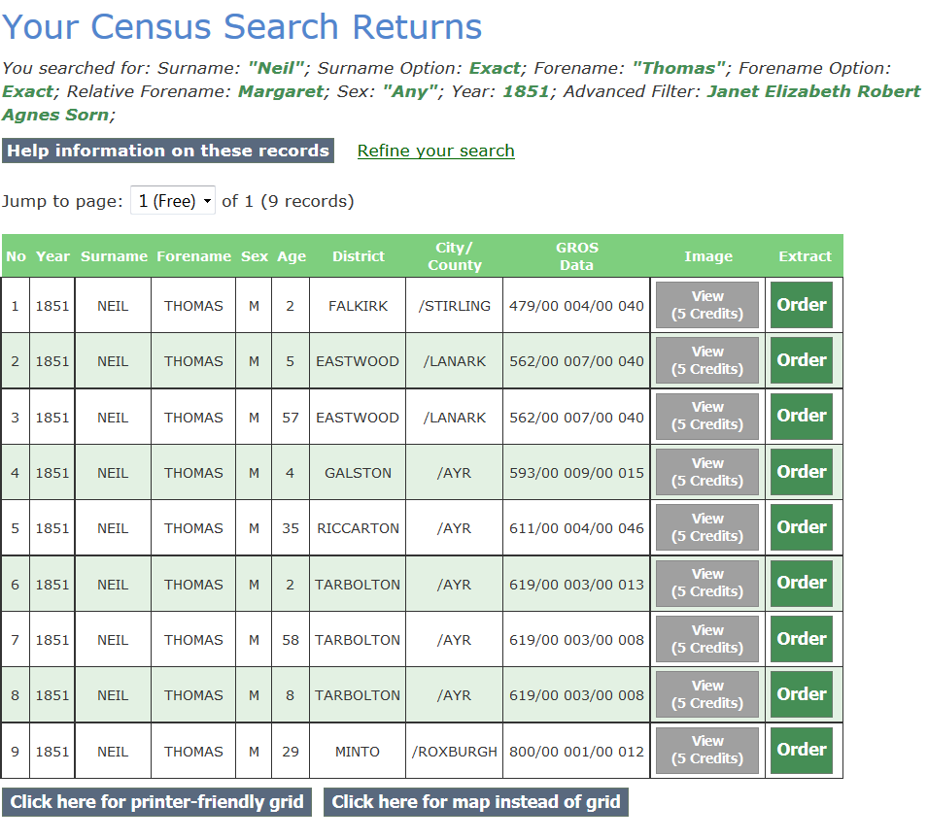
Clearly the two Thomas Neils as in Eastwood District are the same return and the Thomas we were interested in was supposed to have resided in Coustonholm at his death in 1854. (which according to Elizabeth Smith is in Eastwood) so looked at the census return and it showed :

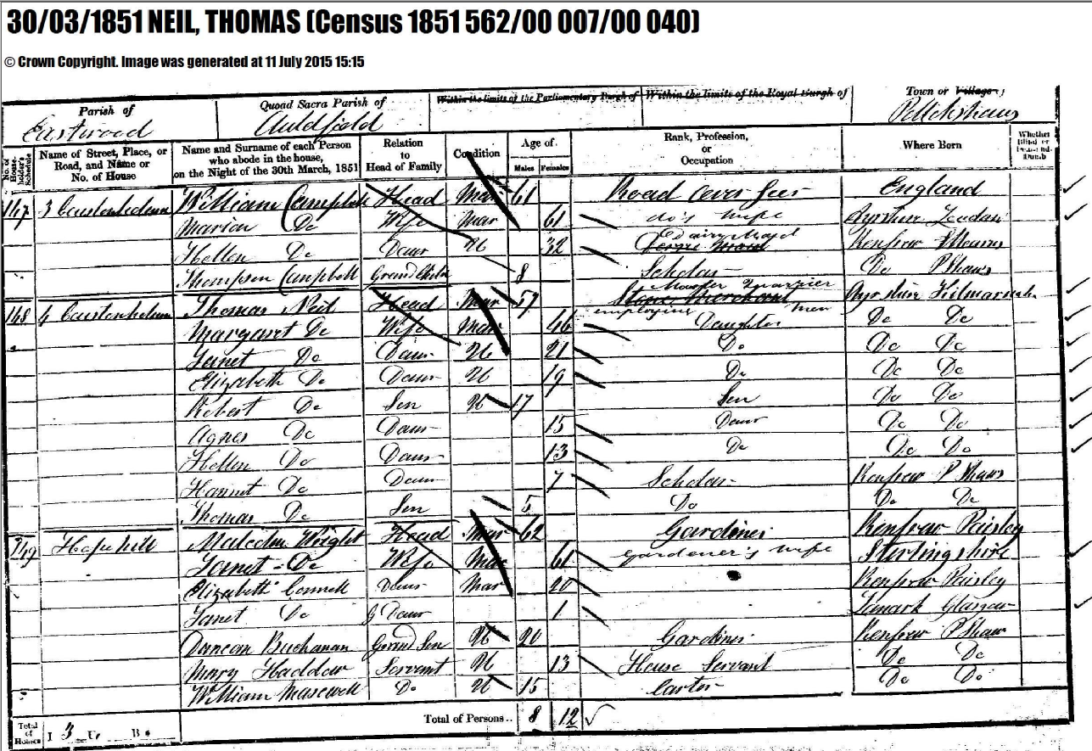
This reads : Parish of Eastwood, Quoad Sacra Parish of Auldfield, Town of Pollockshaws Entry No 168, 4 Coustonholm
Thomas Neil | Head | Mar | 57 |  | Master Quarrier employing men (Stone Merchant is crossed out) | Ayrshire, Kilmarnock
Margaret Neil | Wife | Mar |  | 46 | Daughter (sic) | Ayrshire, Kilmarnock
Janet Neil | Daur | U |  | 21 | Daughter | Ayrshire, Kilmarnock
Elizabeth Neil | Daur | U |  | 19 | Daughter | Ayrshire, Kilmarnock
Robert Neil | Son | U | 17 |  | Son | Ayrshire, Kilmarnock
Agnes Neil | Daur |  |  | 15 | Daughter | Ayrshire, Kilmarnock
Hellen Neil | Daur |  |  | 13 | Daughter | Ayrshire, Kilmarnock
Harriet Neil | Daur |  |  | 7 | Scholar | Renfrew ????
Thomas Neil | Son |  | 5 |  | Scholar | Renfrew ????

This confirms that Harriet and Thomas did belong to these parents but also adds another child, Hellen, born circa 1838. This raises a curious problem; the ages of the children given in the census are almost 2 years older than the ages returned by the LDS query in all cases where there was an LDS mention of the child. Thomas's age seems right but Margaret is possibly a couple of years out as well. What we do not find here, obviously, is a James that the gravestone inscription mentions as dying 8th November 1839 but, more curiously, we could find no reference to this death in the parish registers either.
I decided to look back at the 1841 Census to see if I could find the family then.

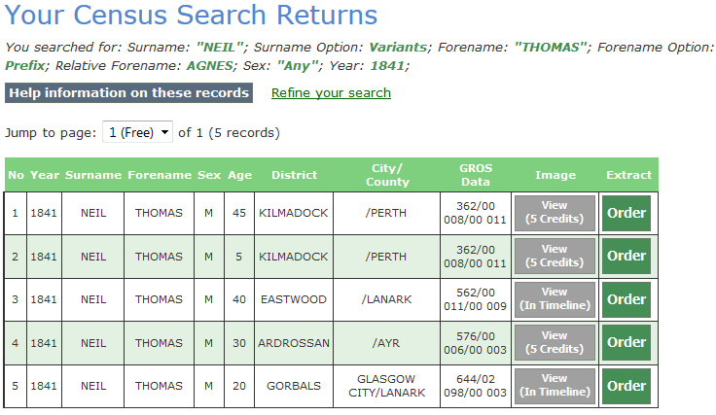
There were two families here but obviously the Eastwood one was the more likely. I looked up the page and found them thus :
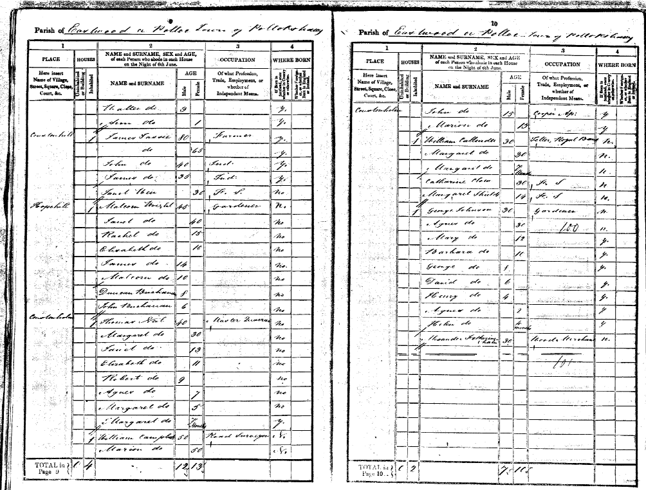

The entry reads
06/06/1841 Neil, Thomas (Census 1841 562/00 011/00 009
Parish of Eastwood or Polloc Town of Pollockshaw (?)
Address : Coustonholm
Name | Age M | Age F | Profession etc | This County
Thomas Neil | 40 |  | Master Quarrier | No
Margaret Neil |  | 30 |  | No
Janet Neil |  | 13 |  | No
Elizabeth Neil |  | 11 |  | No
Robert Neil | 9 |  |  | No
Agnes Neil |  | 7 |  | No
Margaret Neil |  | 5 |  | No
Margaret Neil |  | 7 mo |  | Yes

As well as the children mentioned previously we also find not one but two Margarets (??) Margaret Neil aged 5 years so born 1837 and Margaret Neil aged 7 months, so born 1840. According to the gravestone she died 2 July 1844. This brings all the known children into the picture as far as the census is concerned except James who died 8 November 1839 before either of these censuses. On the matter of two children in the same family having the same name there is some discussion of this at http://www.rootschat.com/forum/index.php?topic=616324.0
From all of the above it is hard to see where our John Neil would fit into all of this and so we have to conclude that this is not the Thomas Neil who was the father of Our John Neil who was born 14th April 1836 and baptised 4th July 1836, the lawful son of Thomas Neill and Agnes Feran despite the connection that Matt Neil seems to have made.
When I did the reconstruction of the children of this family including OPR mentions, the 1851 census and the information from the gravestone, I was stuck by the longevity of some of these children and started wondering if I had got the births of some people and the deaths of other people. In particular I looked at Janet Neil b 24/4/1828 Sorn and who the gravestone said died 2/9/1920 This would have made her about 90 - 92 years of age at death. Her mother had died aged 85 but this still seemed suspicious so I looked up deaths of Janet Neils (in case she had not married) :

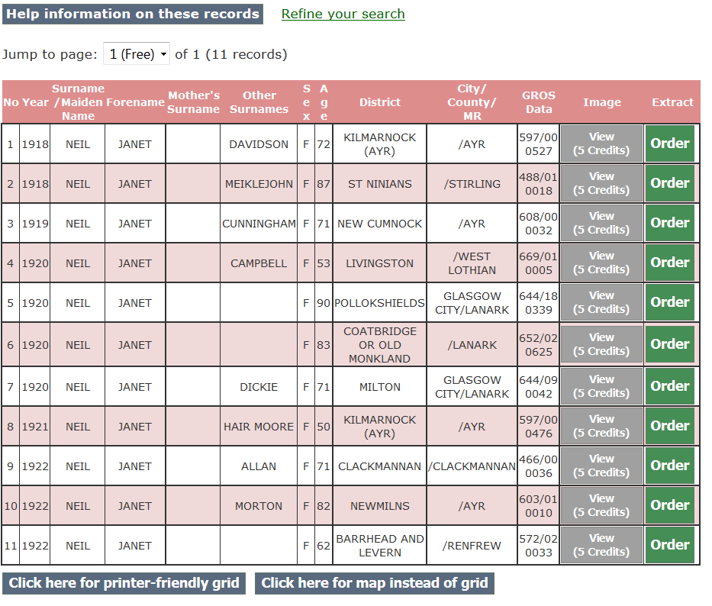

The likely entry would be the one for a Janet Neil who died in Pollockshields aged 90 so I looked at the certification :
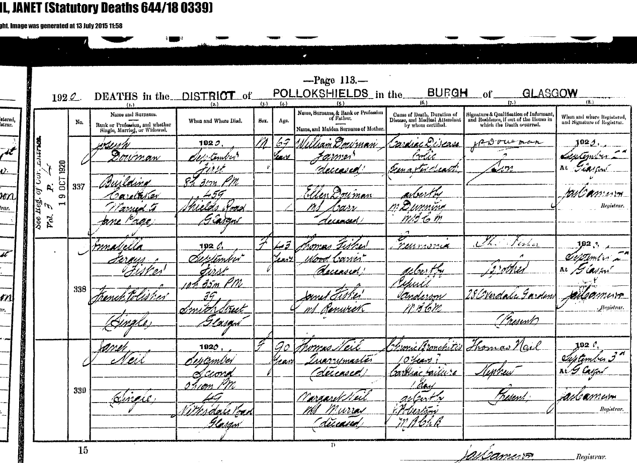

The register of the deaths in the district of Pollockshields in the burgh of Glasgow for 1920 (entry no 330) records the death of Janet Neil, Single who died 0h10m PM (?) on the 2nd of September at 49 Nithsdale Road, Glasgow aged 90 years. She died of Chronic Bronchitis 10 years, Cardiac Failure 1 day. She was the daughter of Thomas Neil, Quarrymaster (deceased) and Margaret Neil ms Murray (deceased). The informant was Thomas Neil, Nephew, who was present.

Unable to make a connection between this family and mine I emailed Elizabeth Smith to say :
Dear Elizabeth,

Thank you very much for the photo and the transcription; I spent some of the weekend looking up the people mentioned and discovered that Margaret Murray married Thomas Neil 22/6/1827 in Sorn, Ayrshire (both were "of this parish") I looked at the IGI and found some children to this couple but in order to find out a bit more I looked at the 1851 census and found them living at 4 Coustonholm : Parish of Eastwood, Quoad Sacra Parish of Auldfield, Town of Pollockshaws Entry No 168.

Thomas Neil Head Mar 57 Master Quarrier employing men (Stone Merchant is crossed out) Ayrshire, Kilmarnock
Margaret Neil Wife Mar 46 Daughter (sic) Ayrshire, Kilmarnock
Janet Neil Daur U 21 Daughter Ayrshire, Kilmarnock
Elizabeth Neil Daur U 19 Daughter Ayrshire, Kilmarnock
Robert Neil Son U 17 Son Ayrshire, Kilmarnock
Agnes Neil Daur 15 Daughter Ayrshire, Kilmarnock
Hellen Neil Daur 13 Daughter Ayrshire, Kilmarnock
Harriet Neil Daur 7 Scholar Renfrew, Mearns ?
Thomas Neil Son 5 Scholar Renfrew, Mearns ?

It has to be said that there is an approximately two year difference between some of the ages as given in the census and other sources I looked at.

The gravestone, though, mentions other children - James who died 8 November 1839 and Margaret who died 2 July 1844. It is possible that these children died at birth and that the order of the children was like this :

Janet b 24/4/1828 Sorn d 2/9/1920 (according to gravestone)
Elizabeth b 6/4/1830 Sorn
Robert b 2/9/1832 Sorn d 17/12/1874 at Rodney Downs, Queensland (according to gravestone)
Agnes b 25/7/1834 Sorn d 2/4/1917 (according to gravestone)
Hellen b circa 1836 Sorn
James b ? d 8/11/1839 (according to gravestone)
Harriet b 6/9/1842 Renfrew
Margaret b ? d 2/7/1844 (according to gravestone)
Thomas b 10/11/1846 Renfrew d 10/5/1886 (according to gravestone)

I also found the death registration of Margaret Neil (nee Murray) in 1888. She was Margaret Neil, widow of Thomas Neil, Quarry Master and died 10pm on 6th of July 1888 aged 85 at 114 South Portland Street, Glasgow. Her father was James Murray, House Builder (Master deceased). Her mother was Janet Murray ms Mc. Meekin (?) (deceased). She died of General Exhaustion from Old Age and the informant was her daughter Agnes.
So, all in all, I can't find any way of connecting the Thomas Neil, father of this family, to the Thomas Neil who was married to Agnes Feran and whose son, John, was born 14th April 1836 and baptised 4th July 1836 at St. Andrew's Cathedral. This family also seem to be of a rather "better" class of people than my ancestors so I don't think I can add these people to my family tree in any obvious way yet.
As I mentioned earlier Matthew Neil or his father Gordon Neil seemed to think that our common ancestor, John Neil, had a father who is described in the death register for Cathcart thus : "7th February 1854 (registered) Thomas Neil Quarrier residing at Coustonholm died of Cholera on the 7th February 1854 aged 60".This is clearly the same person referred to in the gravestone you sent me the photo of and, as I say, it is obviously not the father of my our ancestor. Whether they just found the only death of a Thomas Neil they could find in roughly the right place and roughly the right time and settled on that I don't know. It still remains a mystery.
On the plus side, I had a good few hours looking into this family and enjoyed myself doing so; and who knows when it might prove of interest to someone else or even fit into "mine" in some indirect way. Either way it has got me back into the family history groove so I will have to get back to my Thomas Neil and Agnes Feran again now. Perhaps I should be looking in the poor law records or the police records ?

Anyway, thank you again for your interest and I hope you have a breakthrough in your own researches; one never knows when something might appear !

Very best wishes

Bill Neil

Ps would you happen to have any information on who had the gravestone erected and when ?

